# A

**MINI PROJECT REPORT**

# On

## “Diabetes Prediction Using Machine Learning”

**Submitted To:**



## GRAPHIC ERA (DEEMED TO BE) UNIVERSITY

**For Fulfilment of the Award of the Degree**

## Bachelor of Technology, V Semester Session (2021-22)

### In SOFTWARE ENGINEERING

**Submitted By: - Guided By: Name:Akhilesh kumar Miss. Meenakshi Maindola**

### University Roll No: 2014542 Enrollment No: GE-192014542

**ABSTRACT**

Diabetes is an illness caused because of high glucose level in a human body. Diabetes should not be ignored if it is untreated then Diabetes may cause some major issues in a person like: heart related problems, kidney problem, blood pressure, eye damage and it can also affects other organs of human body. Diabetes can be controlled if it is predicted earlier. To achieve this goal this project work we will do early prediction of Diabetes in a human body or a patient for a higher accuracy through applying, Various Machine Learning Techniques. Machine learning techniques Provide better result for prediction by constructing models from datasets collected from patients. In this work we will use Machine Learning Classification and ensemble techniques on a dataset to predict diabetes. Which are K- Nearest Neighbor (KNN), Logistic Regression (LR), Decision Tree (DT), Support Vector Machine (SVM), Gradient Boosting (GB) and Random Forest (RF). The accuracy is different for every model when compared to other models. The Project work gives the accurate or higher accuracy model shows that the model is capable of predicting diabetes effectively.

Our Result shows that Random Forest achieved higher accuracy compared to other machine learning techniques.

**Keywords: Diabetes, Machine, Learning, Prediction, Dataset, Ensemble.**

### INTRODUCTION

Diabetes is noxious diseases in the world. Diabetes caused because of obesity or high blood glucose level, and so forth. It affects the hormone insulin, resulting in abnormal metabolism of crabs and improves level of sugar in the blood. Diabetes occurs when body does not make enough insulin. According to (WHO) World Health Organization about 422 million people suffering from diabetes particularly from low or idle income countries. And this could be increased to 490 billion up to the year of 2030. However prevalence of diabetes is found among various Countries like Canada, China, and India etc. Population of India is now more than 100 million so the actual number of diabetics in India is 40 million. Diabetes is major cause of death in the world. Early prediction of disease like diabetes can be controlled and save the human life. To accomplish this, this work explores prediction of diabetes by taking various attributes related to diabetes disease. For this purpose we use the Pima Indian Diabetes Dataset, we apply various Machine Learning classification and ensemble Techniques to predict diabetes. Machine Learning Is a method that is used to train computers or machines explicitly. Various Machine Learning Techniques provide efficient result to collect Knowledge by building various classification and ensemble models from collected dataset. Such collected data can be useful to predict diabetes. Various techniques of Machine Learning can capable to do prediction, however it’s tough to choose best technique.

Thus for this purpose we apply popular classification and ensemble methods on dataset for prediction.

### LITERATURE REVIEW

K.VijiyaKumar et al. [11] proposed random Forest algorithm for the Prediction of diabetes develop a system which can perform early prediction of diabetes for a patient with a higher accuracy by using Random Forest algorithm in machine learning technique. The proposed model gives the best results for diabetic prediction and the result showed that the prediction system is capable of predicting the diabetes disease effectively, efficiently and most importantly, instantly. Nonso Nnamoko et al. [13] presented predicting diabetes onset: an ensemble supervised learning approach they used five widely used classifiers are employed for the ensembles and a meta-classifier is used to aggregate their outputs. The results are presented and compared with similar studies that used the same dataset within the literature. It is shown that by using the proposed method, diabetes onset prediction can be done with higher accuracy. Tejas N. Joshi et al. [12] presented Diabetes Prediction Using Machine Learning Techniques aims to predict diabetes via three different supervised machine learning methods including: SVM, Logistic regression, ANN. This project proposes an effective technique for earlier detection of the diabetes disease. Deeraj Shetty et al. [15] proposed diabetes disease prediction using data mining assemble Intelligent Diabetes Disease Prediction System that gives analysis of diabetes malady utilizing diabetes patient’s database. In this system, they propose the use of algorithms like Bayesian and KNN (K- Nearest Neighbor) to apply on diabetes patient’s database and analyze them by taking various attributes of diabetes for prediction of diabetes disease. Muhammad Azeem Sarwar et al. [10] proposed study on prediction of diabetes using machine learning algorithms in healthcare they applied six different machine learning algorithms Performance and accuracy of the applied algorithms is discussed and compared. Comparison of the different machine learning techniques used in this study reveals which algorithm is best suited for prediction of diabetes. Diabetes Prediction is becoming the area of interest for researchers in order to train the program to identify the patient are diabetic or not by applying proper classifier on the dataset. Based on previous research work, it has been observed that the classification process is not much improved. Hence a system is required as Diabetes Prediction is important area in computers, to handle the issues identified based on previous research.

### PROPOSED METHODOLOGY

Goal of the paper is to investigate for model to predict diabetes with better accuracy. We experimented with different classification and ensemble algorithms to predict diabetes. In the following, we briefly discuss the phase.

1. **Dataset Description**- the data is gathered from UCI repository which is named as Pima Indian Diabetes Dataset. The dataset have many attributes of 768 patients.

#### Table 1: Dataset Description

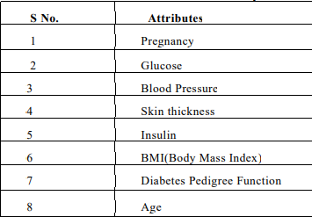

The 9th attribute is class variable of each data points. This class variable shows the outcome 0 and 1 for diabetics which indicates positive or negative for diabetics.

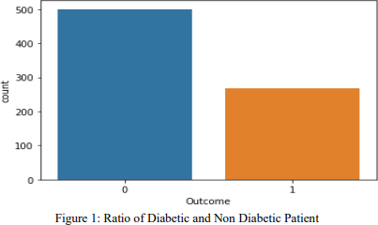**Distribution of Diabetic patient**- We made a model to predict diabetes however the dataset was slightly imbalanced having around 500 classes labeled as 0 means negative means no diabetes and 268 labeled as 1 means positive means diabetic.

1. Data Preprocessing- Data preprocessing is most important process. Mostly healthcare related data contains missing vale and other impurities that can cause effectiveness of data. To improve quality and effectiveness obtained after mining process, Data preprocessing is done. To use Machine Learning Techniques on the dataset effectively this process is essential for accurate result and successful prediction. For Pima Indian diabetes dataset we need to perform pre processing in two steps.
2. **Missing Values removal**- Remove all the instances that have zero (0) as worth. Having zero as worth is not possible. Therefore this instance is eliminated. Through eliminating irrelevant features/instances we make feature subset and this process is called features subset selection, which reduces diamentonality of data and help to work faster.
3. **Splitting of data-** After cleaning the data, data is normalized in training and testing the model. When data is spitted then we train algorithm on the training data set and keep test data set aside. This training process will produce the training model based on logic and algorithms and values of the feature in training data. Basically aim of normalization is to bring all the attributes under same scale.
4. **Apply Machine Learning**- When data has been ready we apply Machine Learning Technique. We use different classification and ensemble techniques, to predict diabetes. The methods applied on Pima Indians diabetes dataset. Main objective to apply Machine Learning Techniques to analyze the performance of these methods and find accuracy of them, and also been able to figure out the responsible/important feature which play a major role in prediction. The Techniques are follows
5. **Support Vector Machine**- Support Vector Machine also known as svm is a supervised machine learning algorithm. Svm is most popular classification technique. Svm creates a hyperplane that separate two classes. It can create a hyperplane or set of hyperplane in high dimensional space. This hyper plane can be used for classification or regression also. Svm differentiates instances in specific classes and can also classify the entities which are not supported by data. Separation is done by through hyperplane performs the separation to the closest training point of any class.

#### Algorithm-

* Select the hyper plane which divides the class better.
* To find the better hyper plane you have to calculate the distance between the planes and the data which is called Margin.
* If the distance between the classes is low then the chance of miss conception is high and vice versa. So we need to
* Select the class which has the high margin. Margin = distance to positive point + Distance to negative point.

1. **K-Nearest Neighbor -** KNN is also a supervised machine learning algorithm. KNN helps to solve both the classification and regression problems. KNN is lazy prediction technique. KNN assumes that similar things are near to each other. Many times data points which are similar are very near to each other .KNN helps to group new work based on similarity measure. KNN algorithm record all the records and classify them according to their similarity measure. For finding the distance between the points uses tree like structure. To make a prediction for a new data point, the algorithm finds the closest data points in the training data set — it’s nearest neighbors. Here K= Number of nearby neighbors, it’s always a positive integer. Neighbor’s value is chosen from set of class. Closeness is mainly defined in terms of Euclidean distance. The Euclidean distance between two points P and Q i.e. P (p1,p2, …. Pn) and Q (q1, q2,..qn) is defined by the following equation:-

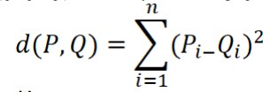

#### Algorithm-

* Take a sample dataset of columns and rows named as Pima Indian Diabetes data set.
* Take a test dataset of attributes and rows.
* 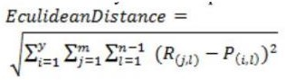Find the Euclidean distance by the help of formula-
* Then, Decide a random value of K. is the no. of nearest neighbors
* Then with the help of these minimum distance and Euclidean distance find out the nth column of each.
* Find out the same output values. If the values are same, then the patient is diabetic, otherwise not.

1. **Decision Tree**- Decision tree is a basic classification method. It is supervised learning method. Decision tree used when response variable is categorical. Decision tree has tree like structure based model which describes classification process based on input feature.

Input variables are any types like graph, text, discrete, continuous etc. Steps for Decision

#### Tree Algorithm-

* Construct tree with nodes as input feature.
* Select feature to predict the output from input feature whose information gain is highest.
* The highest information gain is calculated for each attribute in each node of tree.
* Repeat step 2 to form a subtree using the feature which is not used in above node.

1. **Logistic Regression**- Logistic regression is also a supervised learning classification algorithm. It is used to estimate the probability of a binary response based on one or more predictors. They can be continuous or discrete. Logistic regression used when we want to classify or distinguish some data items into categories. It classify the data in binary form means only in 0 and 1 which refer case to classify patient that is positive or negative for diabetes. Main aim of logistic regression is to best fit which is responsible for describing the relationship between target and predictor variable. Logistic regression is a based on Linear regression model. Logistic regression model uses sigmoid function to predict probability of positive and negative class. Sigmoid function P = 1/1+e - (a+bx) Here P = probability, a and b = parameter of Model.

**Ensembling**- Ensembling is a machine learning technique Ensemble means using multiple learning algorithms together for some task. It provides better prediction than any other individual model that’s why it is used. The main cause of error is noise bias and variance, ensemble methods help to reduce or minimize these errors. There are two popular ensemble methods such as – Bagging, Boosting, ada-boosting, Gradient boosting, voting, averaging etc. Here In these work we have used Bagging (Random forest) and Gradient boosting ensemble methods for predicting diabetes.

1. **Random Forest** – It is type of ensemble learning method and also used for classification and regression tasks. The accuracy it gives is grater then compared to other models. This method can easily handle large datasets. Random Forest is developed by Leo Bremen. It is popular ensemble Learning Method. Random Forest Improve Performance of Decision Tree by reducing variance. It operates by constructing a multitude of decision trees at training time and outputs the class that is the mode of the classes or classification or mean prediction (regression) of the individual trees. **Algorithm**-

* The first step is to select the “R” features from the total features “m” where R<<M.
* Among the “R” features, the node using the best split point.
* Split the node into sub nodes using the best split.
* Repeat a to c steps until ”l” number of nodes has been reached.
* Built forest by repeating steps a to d for “a” number of times to create “n” number of trees. The random forest finds the best split using the Gin-Index Cost Function which is given by:



The first step is to need the take a glance at choices and use the foundations of each indiscriminately created decision tree to predict the result and stores the anticipated outcome at intervals the target place. Secondly, calculate the votes for each predicted target and ultimately, admit the high voted predicted target as a result of the ultimate prediction from the random forest formula. Some of the options of Random Forest does correct predictions result for a spread of applications are offered.

1. **Gradient Boosting** - Gradient Boosting is most powerful ensemble technique used for prediction and it is a classification technique. It combine week learner together to make strong learner models for prediction. It uses Decision Tree model. it classify complex data sets and it is very effective and popular method. In gradient boosting model performance improve over iterations.

#### Algorithm-

* Consider a sample of target values as P
* Estimate the error in target values.
* Update and adjust the weights to reduce error M.
* P[x] =p[x] +alpha M[x]
* Model Learners are analyzed and calculated by loss function F
* Repeat steps till desired & target result P.

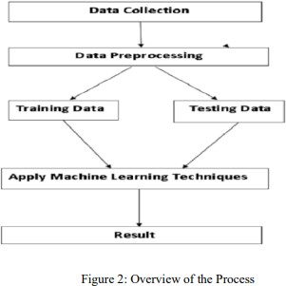

### MODEL BUILDING

This is most important phase which includes model building for prediction of diabetes. In this we have implemented various machine learning algorithms which are discussed above for diabetes prediction.

#### Procedure of Proposed Methodology:

**Step1**: Import required libraries, Import diabetes dataset.

**Step2**: Pre-process data to remove missing data.

**Step3**: Perform percentage split of 80% to divide dataset as Training set and 20% to Test set.

**Step4**: Select the machine learning algorithm i.e. K-Nearest Neighbor, Support Vector Machine, Decision Tree, Logistic regression, Random Forest and Gradient boosting algorithm.

**Step5**: Build the classifier model for the mentioned machine learning algorithm based on training set.

**Step6:** Test the Classifier model for the mentioned machine learning algorithm based on test set.

**Step7:** Perform Comparison Evaluation of the experimental performance results obtained for each classifier.

**Step8**: After analyzing based on various measures conclude the best performing algorithm.

### EXPERIMENTAL RESULTS

In this work different steps were taken. The proposed approach uses different classification and ensemble methods and implemented using python. These methods are standard Machine Learning methods used to obtain the best accuracy from data. In this work we see that random forest classifier achieves better compared to others. Overall we have used best Machine Learning techniques for prediction and to achieve high performance accuracy.

Figure shows the result of these Machine Learning methods.

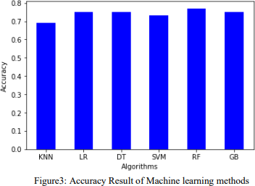

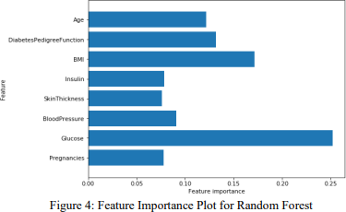Here feature played important role in prediction is presented for random forest algorithm. The sum of the importance of each feature playing major role for diabetes have been plotted, where X-axis represents the importance of each feature and Y-Axis the names of the features.

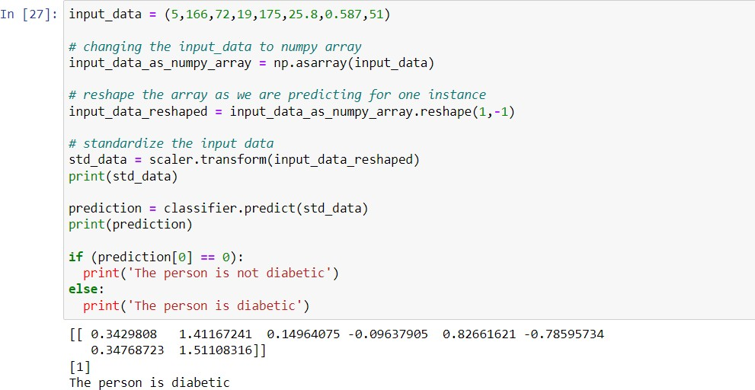

### CONCLUSION

The main aim of this project was to design and implement Diabetes Prediction Using Machine Learning Methods and Performance Analysis of that methods and it has been achieved successfully. The proposed approach uses various classification and ensemble learning method in which SVM, Knn, Random Forest, Decision Tree, Logistic Regression and Gradient Boosting classifiers are used. And 77% classification accuracy has been achieved. The Experimental results can be asst health care to take early prediction and make early decision to cure diabetes and save humans life.